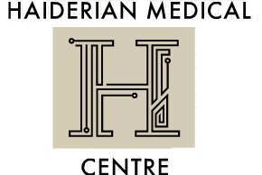

Haiderian Medical Centre
Zero Tolerance Policy
The NHS operate a zero tolerance policy with regard to violence and abuse and the practice has the right to remove violent patients from the list with immediate effect in order to safeguard practice staff, patients and other persons.
Violence in this context includes actual or threatened physical violence or verbal abuse which leads to fear for a person’s safety. In this situation we will notify the patient in writing of their removal from the list and record in the patient’s medical records the fact of the removal and the circumstances leading to it.
We ask that you treat all staff courteously, and in return, expect the same from us.

